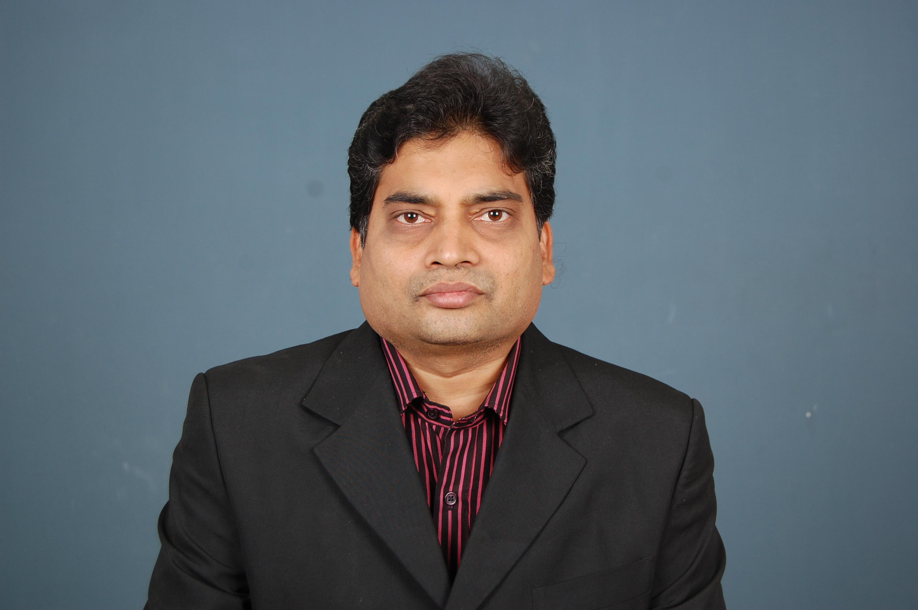 Brief Profile of CA.V.M.V.Subba Rao
- Commerce Graduate from S.V.University, Tirupati

- Fellow Member of Institute of Chartered Accountants of India, New Delhi

- Qualified Information Systems Auditor as certified by ICAI, New Delhi

- Qualified in C A A T programme conducted by ICAI, New Delhi

- Proprietor, V.M.V.S.Rao & Co., Chartered Accountants , Nellore

- More than 17 years of experience in Audit, Taxation and Management Consultancy

- Adviser to reputed Corporate Entities in Nellore

- Co-opted Member of SIRC of ICAI for the year 2005-06

- Vice-Chairman of Nellore Branch of SIRC of ICAI

- Instrumental person bringing the Branch Status and Computer Lab at Nellore Branch

- Organized several CPE Programs/Workshops on topics of professional interest.

- Submitted pre-budged and post-budget memorandum to ICAI

- Presented papers at Study Circle Meetings at Nellore Branch

- Updating members on various professional matters through Group e-mail facility

- Various articles published in professional journals

- Life Member of :
  - Bombay Chartered Accountants Society
  - Karnataka State Chartered Accountants Society
  - All India Federation of Tax Practitioners
  - Chartered Accountants Study Circle, Chennai
  - Association of Certified Fraud Examiners, USA
  - Lions Club of Nellore Pinakini

